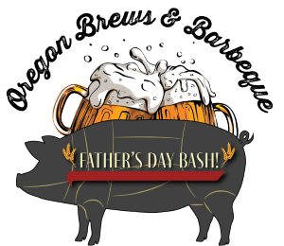

**Sponsorship Agreement Form**

Oregon Brews & BBQ LLC strives to raise awareness about the constant fight that our veterans and active military struggle with on a daily basis, whether it be mental, physical or financial. A percentage of all proceeds in 2025 go to The American Legion Post 21, McMinnville and Wounded Warrior Project.

Oregon Brews & BBQ LLC is committed to providing our community with a quality event for the whole family to enjoy.

Thank you for supporting our mission to help our veterans and active military in their time of need.

Call or e-mail Richard at 971-267-4659 & oregonbrewsandbbqs@gmail.com

**My Organization Wishes to Sponsor**

|  |  |
| --- | --- |
| _____ $ 5,000 Stage Sponsor | _____ $1,000 Mechanical Bull Sponsor |
| _____ $1,000 Medieval Sponsor | _____ $1,000 Axe Throwing Sponsor |
| _____ $1,000 People’s Choice Sponsor | _____ $750 Car/Bike Show Sponsor |
| _____ $500 Hammershlagen Sponsor | _____ $500 Beer Keg Shuffle Board Sponsor |
| _____ $200 Banner II Sponsor | _____ $200 Banner I Sponsor |
| _____ $25 Personal Sponsor |  |

Company Name_______________________________________________________

Address______________________________________________________________

City_____________________________ State________ Zip__________

Date_____________________ Contact #/E-mail_____________________________

Signature_____________________________________________________________

Printed Name__________________________________________________________

Thank you!